Networking for Software Developers
This is a group lab that will contribute towards your final project. One person will submit this work to the group dropbox.

Lab 10 – Display a Dynamic Time Series.
Design and develop a custom line and/or bar chart interface that will facilitate dynamic data ingestion.

Maximum Points:
There is a total of 30 points for this assignment.

Description:
You will display a line and/or bar chart for a dynamic dataset, which will add the capability of dynamically displaying auto-generating and changing data points. Design and develop a Tkinter GUI to display a growing set of values.

Python Frameworks/Modules:
- Tkinter: A package to develop standard graphical user interfaces.
- Threading: An internal module serving as a higher-level threading interface.
- OS: A module for interacting with the operating system, including file and directory management.

Use the following pseudocode as a guide:

Part A:
- Create an additional method that will be executed in a thread. This method will do the following in an infinite loop:
- Remove the first item in the list of values
- Add a new random value to the end of the list
- Call the method to display the list on the canvas
- Sleep for a short while (0.5 of a second).
- The initUI() method must perform the following at the end:
- You may remove the Entry widget. This is not used in this application.
- Create a thread and set the target to the method in step 1
- Set the daemon property of the above thread to True. This will terminate the thread when the GUI closes.
- Start the thread.
- Modify the method that draws the rectangle and line to just draw lines.

Due:
See the course shell.

Submission
- Your code file will be named group_«your_group_number»_dynamic_chart.py e.g., group_1_dynamic_chart.py.
- Must be uploaded to the course dropbox before the deadline.
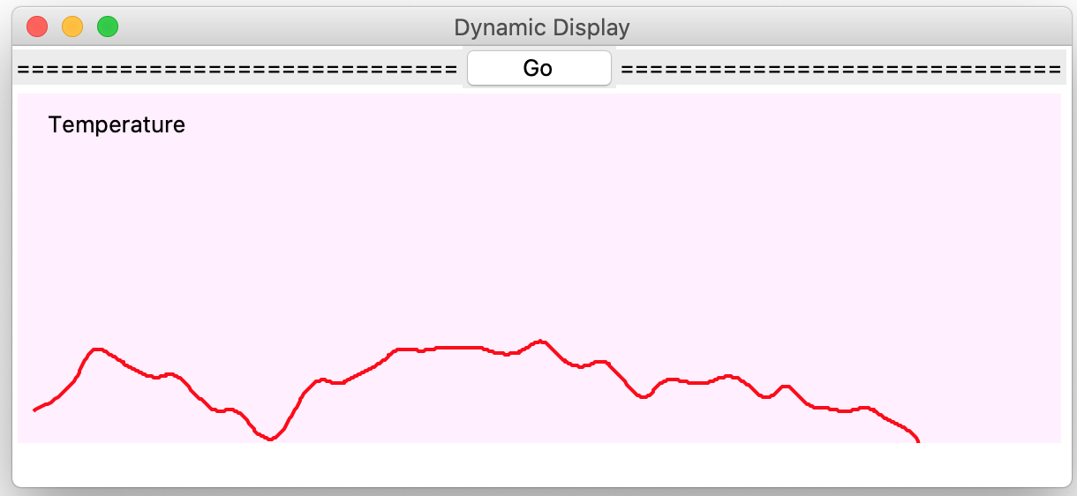
- See the schedule for the due date.

Rubrics
[Class] 4/4
[unitUI Method] 3/3
[Thread Method] 8/8
[Update GUI] 10/10
[GUI] 2/2
[Aesthetics] 3/3
Total 30/30

